Software Requirements Specification
for
Academy Student Portal
Version 1.0 approved
Prepared by Saqib Ali, Shayan Ali Abbasi
Lahore Garrison University
20/5/2019
Table of Contents
Table of Contents ii
Revision History iiii
1. Introduction 1
1.1 Purpose 1
1.2 Document Conventions 1
1.3 Intended Audience and Reading Suggestions 1
1.4 Product Scope 1
1.5 References 1
2. Overall Description 2
2.1 Product Perspective 2
2.2 Product Functions 2
2.3 User Classes and Characteristics 3
2.4 Operating Environment 3
2.5 Design and Implementation Constraints 3
2.6 User Documentation 4
2.7 Assumptions and Dependencies 4
3. External Interface Requirements 4
3.1 User Interfaces 4
3.2 Hardware Interfaces 4
3.3 Software Interfaces 4
3.4 Communications Interfaces 4
4. System Features 5
4.1 Login System 5
4.2 Forgot Password 5
4.3 Main Web-Page 6
4.4 Logging out 6

5. Other Nonfunctional Requirements 7
5.1 Performance Requirements 7
5.2 Safety Requirements 7
5.3 Security Requirements 8
5.4 Software Quality Attributes 8
5.5 Business Rules 8
6. Other Requirements 9
6.1 Database Requirments 9

Appendix A: Glossary 9
Appendix B: Analysis Models 9
Appendix C: To Be Determined List 10

(No revisions)
Revision History
Name | Date | Reason for Changes | Version

Introduction

Purpose
This requirement specification document is written with sole purpose of capturing the requirement of an ‘Academy Student Portal System’. These requirements range from software to hardware and functional to non-functional. These requirements were specified by our customer. This specification document specifies all the sub-system of our products being developed in terms of requirements. This document will help the developers to get a good idea of when they are expected to develop and the stakeholders who will be involved in the development process.

Document Conventions
IEEE standard conventions were followed while writing this document .
Font used for headings is ‘Times’ with size of 18-pixel for main heading and 14 pixels for secondary heading. ‘Arial’ is used for paragraphs with font-size of 11 pixels. Heading are numbered in Arabic numerals; tiered numbers are used as indexes for hierarchical headings. Other than this, there is nothing of significance to be detailed.

Intended Audience and Reading Suggestions
This Software Requirement Specification document is intended for developers, customers, documentation authors. This Software Requirement Specification Document, hereinafter referred to as ‘SRS’, is ordered into different section, intended for different audiences. The subsequent section, ‘Overall description’, describes the system under consideration in summary. Therefore, it is great place to start if you want to know requirements of system in general.
Developers should go through the sections in following sequence: System Features, Other Non-functional requirements, External Interface Requirements, Other Requirements.
Users and customers should go through SRS in following sequence: Overall description, System Features.

Product Scope
These days academies are growing so student need an online platform on which they can track their academic situation or information regularly. To solve student problems, we will build online website for students which will provide services to student. So, we will sell this website system to an academy. We want to facilitate academy to update student about his /her academic situation or information regularly. For this purpose, we are creating a student portal system for an academy. Our goal is to make a fully functional back-end / front-end ready website that will cater to the different tasks related with students of the academy that we are going to sell our website to. This SRS elaborates requirements of mentioned website system.

References
No references are attached with this document.

Overall Description

Product Perspective
‘Student Academy Portal System’ is a new product that we are going to make. This product is begin made for an academy that requires an online mechanism for their student to see and update their personal information as per academy’s record and update it. Such product was never developed by our team before. This is a self-contained product. It is not a follow-on of a product family. Therefore, little to nothing is known or done regarding project of this domain in past.

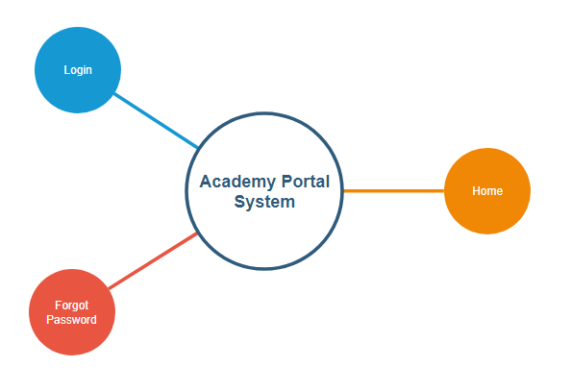

Figure 1: Overall System Overview

Product Functions
This major product functions are listed below.

- It shall allow users to login to their student portal.
- It shall allow users to get their password if they forgot it.
- It shall allow users to go to their portal’s home page after login.
- It shall allow user to update personal information.
- It shall allow user to see academy related information.
- It shall allow users to log out of their portal’s home page.

These requirements are demonstrated in terms of high-level data flow diagram below.
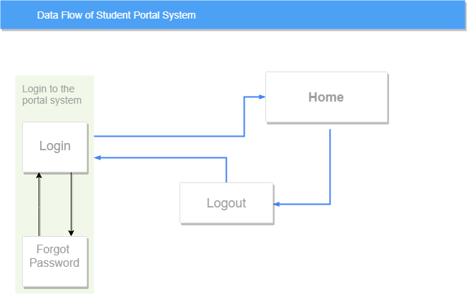

Figure 2: General information flow of system

User Classes and Characteristics

This product will be used by the student of the academy. User will not require much technical expertise to use this product. Just general interaction and knowledge of how website work will be enough for user to understand the system. As, the users will be students, the class going to use our product will be literate. Satisfaction of students is the focus of our product. Hence, they are the major target user class for our product. No other user class will particularly interact with other product.

Operating Environment
Our product is going to run on Windows operating system. It will run on machine that will be a web-server. This web-server will have server-end powerful CPU, high hard-disk storage, and large RAM to accommodate hundreds of users concurrently accessing information from the database.

Design and Implementation Constraints
This product requires backend functionality therefore the server-side language chosen for this task in PHP. HTML, CSS, and JavaScript will accompany PHP to create the front-end of our student portal system. The convention described by the standards of these languages must be followed by the developers. No other language must be used in making of this product.

User Documentation
No user documentation is being referred to by this SRS.

Assumptions and Dependencies
No assumptions were made while writing SRS document. This product has no dependencies on existing software components.

External Interface Requirements

User Interfaces
User interface is necessary for product to be made. Student, which are the main users of our system will interact with our system through GUI (Graphical User Interface). Different user interface requirements are mentioned below.

User interface of the product shall be implemented with HTML and CSS.
To make the interface more dynamic JavaScript shall be used by the developers.
The interface shall be compatible will all modern browsers.
All different browsers student can open the website on, shall be taken into consideration.
There shall be a form to prompt user to enter academy credentials to login.
Meaningful errors message shall be displayed if there is a system or user error.
Consistent interface design shall be used throughout the product.

Hardware Interfaces
Our product will run on internet. Therefore, all hardware our product will run, shall be capable of connecting with devices and external hardware interfaces like router, ethernet cables and devices that provide internet connectivity.

Software Interfaces
Our product will query student information for database. Therefore, there shall be a choice of Relational Database Management System which will store and manage information of students in the academy’s record. Customer already have a database maintained in Microsoft’s SQL Server RDBMS (Relation Database Management System).
Thus, product shall be able to integrate with SQL Server.
Our product shall interact with no other external software.

Communications Interfaces
‘Student Academy Portal System’ shall use HTTPS to securely communicate data over internet.
SSL shall be used for secure data sharing from database over internet.
Uploading of data shall be talked with HTML’s standard FTP (file transferred protocol).

System Features
This section includes the ‘functional requirements’ of our product. <This template illustrates organizing the functional requirements for the product by system features, the major services provided by the product. You may prefer to organize this section by use case, mode of operation, user class, object class, functional hierarchy, or combinations of these, whatever makes the most logical sense for your product.>

Login System
4.1.1 Description and Priority
The main curst of our product is Login System that will provide users (students of academy) access to their portal. This is a high priority system requirement. Without this, all subsequent system features will be unusable.
4.1.2 Stimulus/Response Sequences
This feature will activate when the user will go the academy portal website. User will be first asked to login to the system using academy’s provided credentials.
4.1.3 Functional Requirements

REQ-1: User shall be able to enter his/her academy provided roll number.
REQ-2: User shall be able to enter his/her password.
REQ-3: User shall be able to reset entered details.
REQ-4: User shall be able to submit entered details.
REQ-5: User shall get error message if login fails.
REQ-6: User shall have an option to get his password sent to his email.
REQ-7: The credentials shall be authenticated across academy’s database securely.
REQ-8: System shall give meaningful feedback on user’s actions.

Forgot Password
4.2.1 Description and Priority
Often time, student will forget them password for academy portal. This subsection of product allows student to reset password using email accounts associated with their portal account. This is a medium priority requirement.
4.2.2 Stimulus/Response Sequences
This feature will be activated from login page when the user will click on a link which shall prompt user if they forgot their password. This will be subpage of our website.
4.2.3 Functional Requirements

REQ-9: User shall be able to enter his/her email address.
REQ-10: User shall be able to reset his/her inputted email address.
REQ-11: User shall be able to submit his
REQ-12: User shall get error message if address is not found in record.
REQ-13: System shall only allow valid email addresses.

Main Web-Page
4.3.1 Description and Priority
This will be the place where user will be able to see all this record regarding academics, finance, and courses. User will be able to update his personal information for academy to keep track of like contact details and picture. This is a high priority requirement.
4.3.2 Stimulus/Response Sequences
After successful login. User shall be able to come to this main section of our product.
4.3.3 Functional Requirements
REQ-14: Main web-page of portal system shall be further categorized into following subpages, which shall be shown in a navigation bar:

Home
Personal Information
Academic Information
Financial Information
Library Information
Transferred Courses
Change Email
Change Password
Change Picture
Update Personal Info

REQ-15: After login, user shall be greeted on the home page.
REQ-16: Home page shall have picture on top and different card’s referring user to different subpages within this main page of this portal system.
REQ-17: User shall be able to see his/her personal information like contact details, name, father name in Personal Information subpage.
REQ-18: User shall be able to see his/her financial information like fee details, fines details, Financial Information subpage.
REQ-19: User shall be able to see his academic information like grades in courses he/she is taking in the academy in academic subpage.
REQ-20: Details like any lent book by user from the academy’s library shall be shown in library Information subpage.
REQ-21: Details pertaining to transferred courses from other branches of the academy shall be shown to user in transferred courses subpage.
REQ-22: User shall be able to change his/her email in change email subpage.
REQ-23: System shall validate new email and check whether entered email is already in database on no. If so, give error.
REQ-24: User shall be able to change his/her portal password in change password subpage.
REQ-25: Password shall be asked to re-enter to confirm and it shall only allow strong passwords.
REQ-26: User shall be able to change his/her picture associated with portal through change picture subpage
REQ-27: System shall only allow images with “png” file extension.
REQ-28: System shall allow user to change his contact details like phone number, postal address through change personal info subpage.
REQ-29: In performing all tasks, system shall give readable and understandable error messages to user if any thing goes right or most importantly ‘wrong’.

Logging out
4.4.1 Description and Priority
After user will start a session with ‘logging in’ to the system. There must be mechanism for him/her to log out of the system. This feature will allow user to logout of the system so any other user can login on the system machine. This is a medium priority requirement.
4.4.2 Stimulus/Response Sequences
User can interact with this feature on the main-page of the portal system where he would get after logging into the system. This will take user back to the login page.
4.4.3 Functional Requirements

REQ-30: User shall be able to logout of the main-page of portal system.
REQ-31: User shall only be able to get to this feature after he shall login to system.
REQ-32: This feature shall be hidden when user is logged out of system.
REQ-33: User shall get to homepage after logging out.
REQ-34: System shall clear the current session when user deliberately selects mechanism to logout.
REQ-35: System shall log out user when he/she closes the internet browser portal was opened on.

Other Nonfunctional Requirements

Performance Requirements
The performance of our project is very smooth and very high. It does not strike in between when the user used it. It is an easy understanding of every single user which increased its performance. It is loading very quickly which is a very important part if any project and it is the main requirement of every single user.

Example:
If we load our login page it is loaded almost 2 sec that shows the performance of our system of very high.

Safety Requirements
We can make the backup of any disaster situation like human-made disasters (burst of system etc.) natural dusters (flood etc.) through this data of the user is secured. We create a different type of safety guards through this we are already informed from any cyber-related activities or if someone tries to play our privacies.

Security Requirements
Our system is very secure we fix several checks to prevent it from any type of cyber-attack, spyware, and malware. We also ensure to secure the data, information, and files of the use. We just only authorized the user to access it through this risk of privation of data is minimized.
Example:
Only the administrator can control the privacy policy of the software.

Software Quality Attributes
Usability:
The usability of our project is fine. It shall not put any those function which is very difficult to understand. Once the user views it is very easy to understand very operation or function which we put in it. Our software is for every people mean we put whose operations belong to human understanding which also increased the efficiency of the system and hence user feel very relax and comfortable.

Example:
We place a login page very first it is understood by every single user.

Scalability:
Student portal should hold and handle large data of student that increase with time. In academies number of students is increase with time and data will increase. Our website shall have capacity to handling such large data.

Maintainability:
After giving to the customer we also provide its maintenance after every 6 months so if there are some issues for the user that could be overcome through it, and the user can experience many new features of the software.

Recoverability:
We make the backup to cover the risk of loss of user data and information.

Regulatory:
We keep check and balance of our software and make sure that if there is some issue for the user to user or to operate could be overcome through the regulation of the software.

Capacity:
The capacity of our software is very high. It can accommodate no of users through the database. If we make some changes through the updating according to the user requirements it can also accommodate those changes or functionality.

Business Rules
Student portal should accept unique user id and password which is given by academy.

6 Other Requirements
Database is an integral part of our student portal system for academy. The requirements for database are listed below and are provided by the academy.
6.1 Database Requirements
System shall be able to integrate with Microsoft’s SQL Server RDBMS. System shall only work with the specified database. System shall be able perform query on database. System shall be able to process information form the database. System shall be able to save modified information by the user in the database.
Appendix A: Glossary
Not applicable.

Appendix B: Analysis Models
A general use case model the depicts the interaction of the site user (student) with system is as follows:

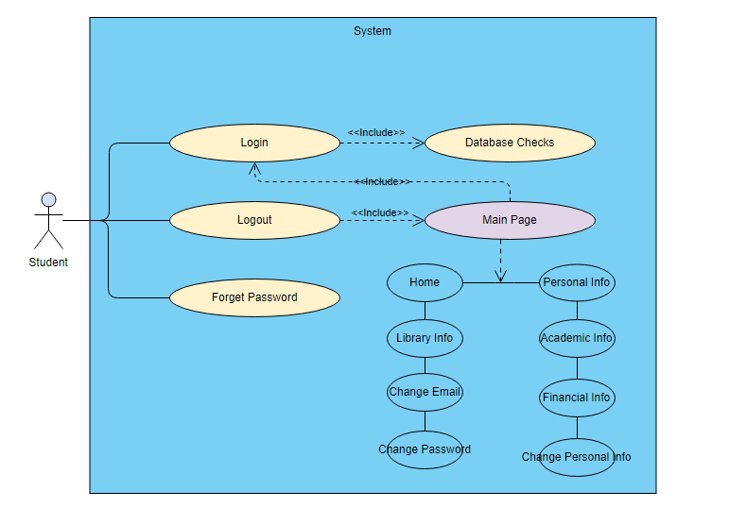

follows

Appendix C: To Be Determined List
Nothing to be determined.

